NITTE MEENAKSHI INSTITUTE OF TECHNOLOGY

(AN AUTONOMOUS INSTITUTION, AFFILIATED TO VISVESVARAYA TECHNOLOGICAL UNIVERSITY, BELGAUM, APPROVED BY AICTE & GOVT.OF KARNATAKA


ML PROJECT REPORT

Baby Cry Classification

Submitted in partial fulfilment of the requirement for the award of Degree of

Bachelor of Engineering

in

Computer Science and Engineering

Submitted by:

Khush Dassani | 1NT18CS074
Abhishek Kushwaha | 1NT18CS212
Gaurav Raj Shah | 1NT18CS195

Under the Guidance of

Dr. Vani V.

Professor, Dept. of CS&E, NMIT


Department of Computer Science and Engineering

(Accredited by NBA Tier-1)

2020-21

NITTE MEENAKSHI INSTITUTE OF TECHNOLOGY

(AN AUTONOMOUS INSTITUTION, AFFILIATED TO VISVESVARAYA TECHNOLOGICAL UNIVERSITY, BELGAUM
, APPROVED BY AICTE & GOVT.OF KARNATAKA)

Department of Computer Science and Engineering

(Accredited by NBA Tier-1)


CERTIFICATE

This is to certify that Baby Cry Classification is an authentic work carried out by Abhishek Kushwaha (1NT18CS212), Gaurav Raj Shah (1NT18CS195), and Khush Dassani (1NT18CS074) bonafide students of Nitte Meenakshi Institute of Technology, Bangalore in partial fulfilment for the award of the degree of Bachelor of Engineering in COMPUTER SCIENCE AND ENGINEERING of Visvesvaraya Technological University, Belagavi during the academic year 2020-2021. It is certified that all corrections and suggestions indicated during the internal assessment has been incorporated in the report.

Internal Guide Signature of H.O.D

Dr. Vani V | Dr. Sarojadevi H.
Professor, Dept. CSE, | Professor, Head, Dept. CSE,
NMIT Bangalore | NMIT Bangalore

DECLARATION

We are hereby declare that

- The project work is our original work

- This Project work has not been submitted for the award of any degree or examination at any other university/College/Institute.
- This Project Work does not contain other persons’ data, pictures, graphs or other information, unless specifically acknowledged as being sourced from other persons.
- This Project Work does not contain other persons’ writing, unless specifically acknowledged as being sourced from other researchers. Where other written sources have been quoted, then:
  - their words have been re-written but the general information attributed to them has been referenced;
  - where their exact words have been used, their writing has been placed inside quotation marks, and referenced.
- This Project Work does not contain text, graphics or tables copied and pasted from the Internet, unless specifically acknowledged, and the source being detailed in the thesis and in the References sections.

Name | USN
Abhishek Kushwaha | 1NT18CS212
Gaurav Raj Shah | 1NT18CS195
Khush Dassani | 1NT18CS074

Date: 17/01/2022

ACKNOWLEDGEMENT

The satisfaction and euphoria that accompany the successful completion of any task would be incomplete without the mention of the people who made it possible, whose constant guidance and encouragement crowned our effort with success. I express my sincere gratitude to our Principal Dr. H. C. Nagaraj, Nitte Meenakshi Institute of Technology for providing facilities.

We wish to thank our HoD, Dr.Sarojadevi H. for the excellent environment created to further educational growth in our college. We also thank him for the invaluable guidance provided which has helped in the creation of a better project.

I hereby like to thank our Dr. Vani V., Professor, Department of Computer Science & Engineering on his periodic inspection, time to time evaluation of the project and help to bring the project to the present form.

Thanks to our Departmental Project coordinators. We also thank all our friends, teaching and non-teaching staff at NMIT, Bangalore, for all the direct and indirect help provided in the completion of the project.

Name | USN | Signature
Abhishek Kushwaha | 1NT18CS212
Gaurav Raj Shah | 1NT18CS195
Khush Dassani | 1NT18CS074

Date: 17/01/2022

ABSTRACT

Neonatal infants communicate with us through cries. The infant cry signals have distinct patterns depending on the purpose of the cries. Preprocessing, feature extraction, and feature selection need expert attention and take much effort in audio signals in recent days. In deep learning techniques, it automatically extracts and selects the most important features. For this, it requires an enormous amount of data for effective classification. This work mainly discriminates the neonatal cries into pain, hunger, and sleepiness. The neonatal cry auditory signals are transformed into a spectrogram image by utilizing the short-time Fourier transform (STFT) technique. The deep convolutional neural network (DCNN) technique takes the spectrogram images for input. The features are obtained from the convolutional neural network and are passed to are passed toother machine learning technique classifies neonatal cries.

Table of Contents

SL No. | Content | Page No.
1 | Introduction | 01
2 | Data Source and Data Quality | 02
3 | Data Pre-processing | 03
4 | Machine Learning Models | 04-07
5 | Implementation and results | 08-
6 | Conclusions
7 | Lessons Learnt
8 | References

INTRODUCTION

Every year, over 130 million infants are born throughout the world. Taking appropriate care of babies, especially for first-time parents, is a huge task. The fundamental reason is because the significance of new-born screams is difficult to decipher. Crying is how infants interact with the outside world. Based on their own experiences, experienced parents, caregivers, physicians, and nurses can recognise the screams. These cries can be put into a machine learning model to figure out why they're crying. Young parents get frustrated and have trouble calming down their babies because all cry signals sound the same to them. Accurately interpreting infants’ cry sounds can help parents take better care of their babies. Building clever technologies that can recognise an infant's scream pave the door for future intelligent robot carers. Disease prediction is another important objective in baby cry research, in addition to understanding new-borns’ everyday requirements. Because various disorders impact an infant's vocal tract and respiratory system, unwell new-borns’ cry signals have distinct features from healthy infants' cry signals.
Motivation-
Babies convey their needs through cries. Experienced baby care persons and parents can understand the reason for the baby's cries. Some young working parents struggled to interpret the baby's cries. The baby's cries imply their emotions, physical needs, and pathological problems from internal or external stimulation. Baby cries contain information, and their crying pattern varies based on their physical and emotional state. The researchers found that there is a pattern for each kind of cry.
Problem domain-
Infant cry classification can be considered pattern recognition or speech recognition.
Aim-
To use machine learning models to discriminate the baby cries as pain, hunger, and sleepiness.

Data source and data quality

We will use the dataset from the Donate-a-cry campaign. The dataset is obtained from the following link –
https://github.com/gveres/donateacry-corpus
This repository contains user-uploaded audio samples in their original, unmodified, unchecked form. The audio samples were uploaded using Donate-a-cry mobile applications for Android and IOS.
The dataset is present wav file and will contain 3000 entries upon conversion.

Data Pre-processing
In our approach, the infant cry signals are taken as input, and short-time Fourier transform (STFT) is deployed to convert the neonatal cry signals into the spectrogram image. The features are extracted from the image using a deep convolutional neural network
Machine Learning Models

k-Nearest Neighbours

K-Nearest Neighbours is one of the simplest Machine Learning algorithms based on Supervised Learning technique. K-NN algorithm assumes the similarity between the new case/data and available cases and put the new case into the category that is most similar to the available categories. In the case of infant cry classification, researchers used Euclidean distance, Minkowski distance, and other methods to measure the distance between two sample feature vectors.
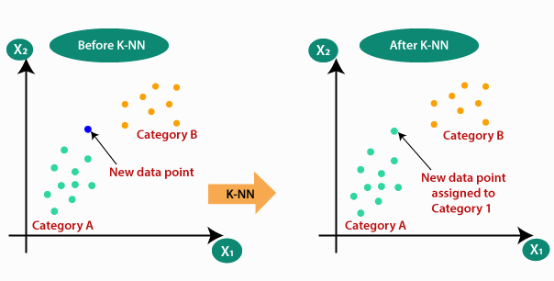

Support Vector Machine

SVM is a supervised machine learning technique that may be used for both classification and regression. Though we might also argue regression difficulties, categorization is the best fit. The goal of the SVM method is to discover a hyperplane in an N-dimensional space that categorises data points clearly. In comparison to other non-linear classifiers such as neural networks, SVMs are intended to operate well with few samples and high-dimensional data.
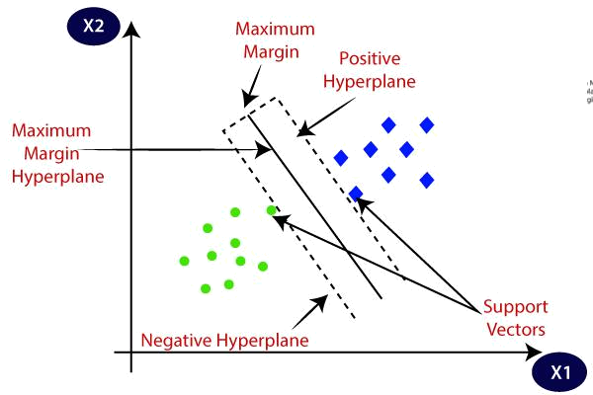

DESIGN
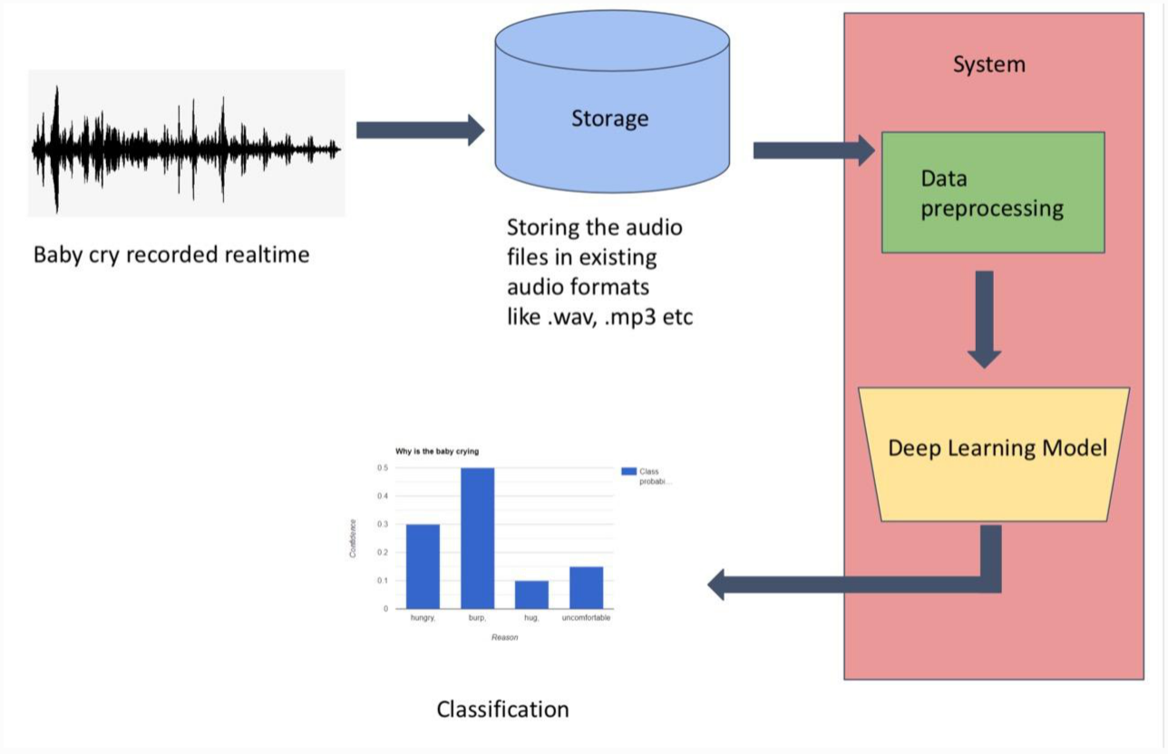
R
SNAPSHOTS OF IMPLEMENTATION
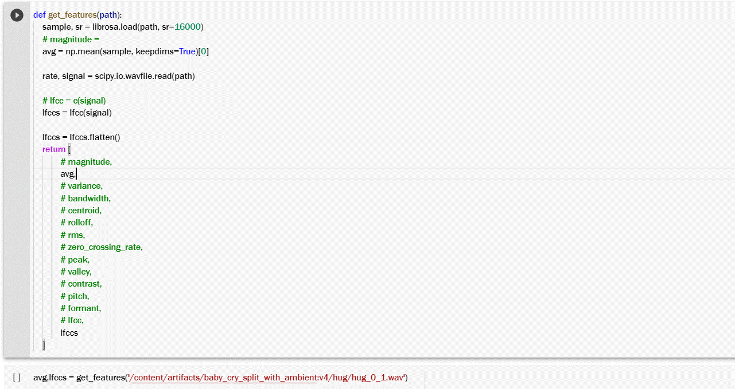
Fig. Feature Extraction
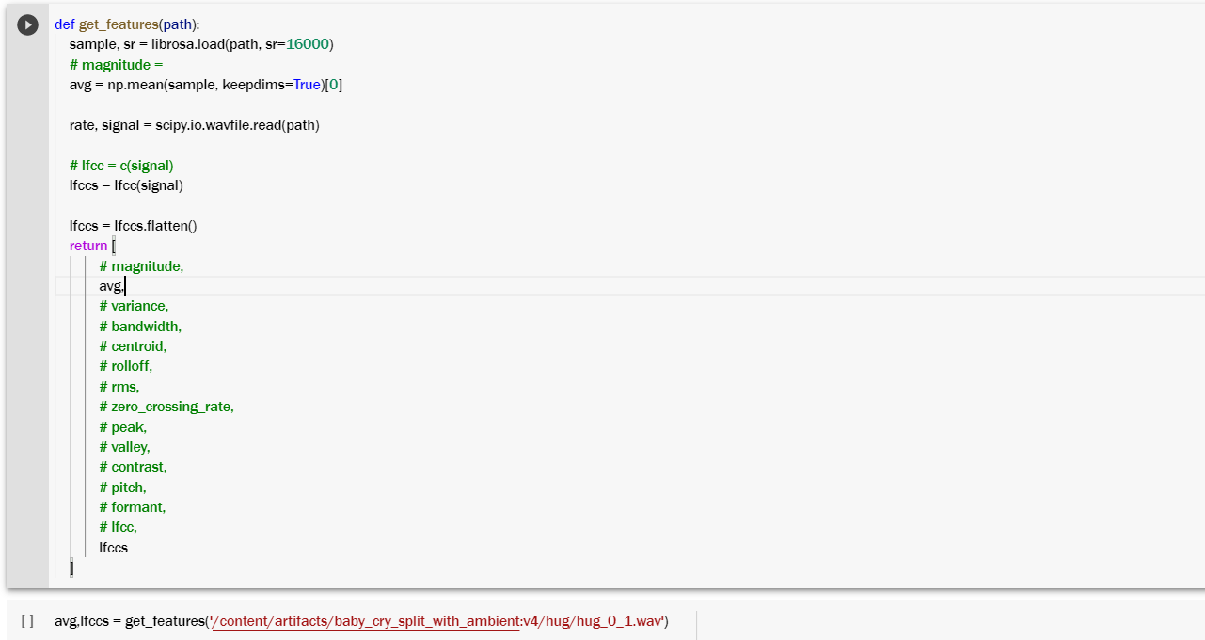

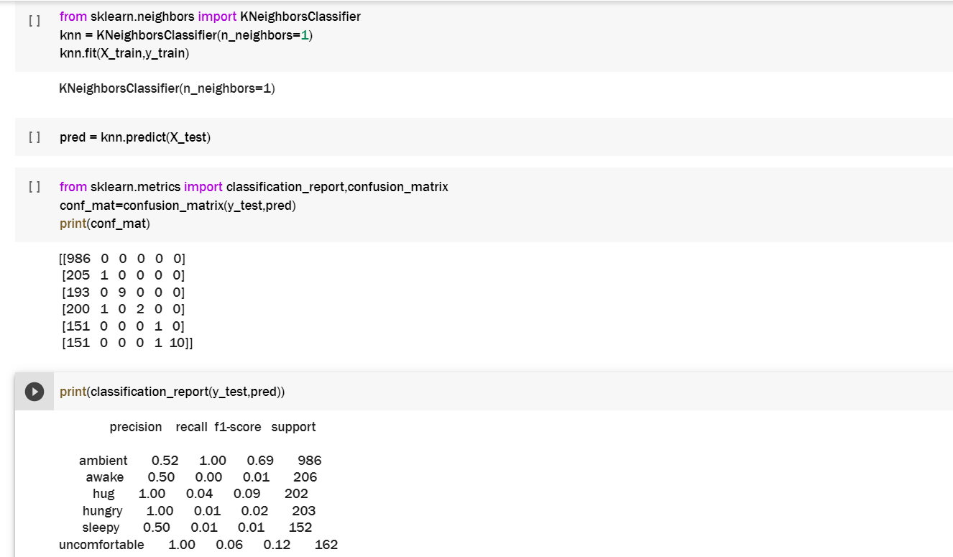
Fig. KNN Implementation
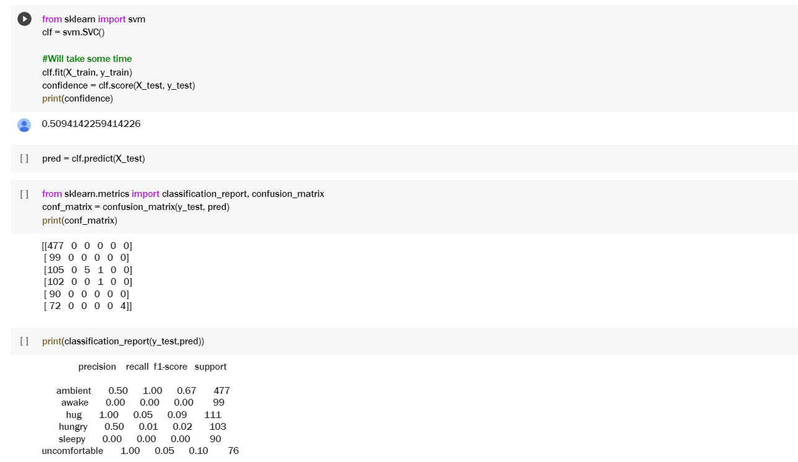
Fig. SVM Implementation

Results
KNN – Accuracy 53%

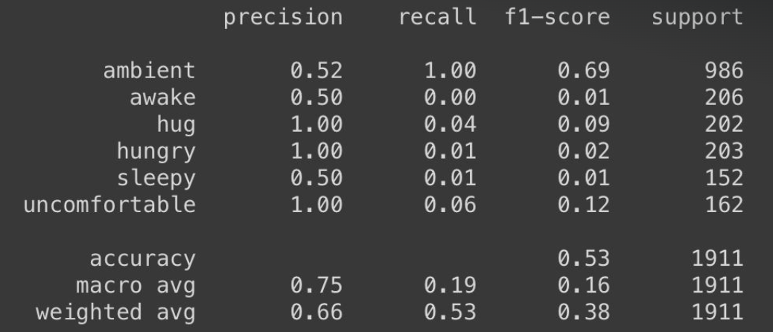

SVM – Accuracy 51%

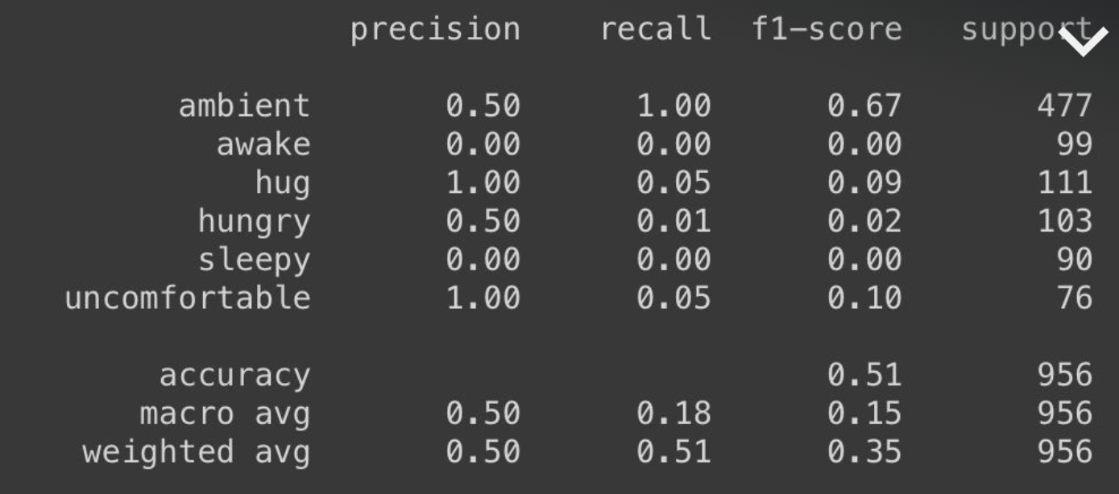
CONCLUSION

This report presents important studies in new-born scream analysis and categorization, giving details and resources for both researchers and medical professionals working in this field. It is demonstrated that the baby cry study is hampered by a lack of database resources. Large datasets with a variety of samples that meet the needs of deep neural networks are essential. To gain superior discriminating ability, the current trend in feature extraction is to build a mixed feature set that takes use of diverse domains. The relevant study findings suggest that combining characteristics can result in a significant improvement. Furthermore, novel neural network-based designs are becoming prevalent.
REFERENCES

- Yuan Gong, Yu-An Chung, James Glass et al, “AST: Audio Spectrogram Transformer” 2021
- Kaiming He, Xiangyu Zhang, Shaoqing Ren, Jian Sun et al, “Deep Residual Learning for Image Recognition” 2015
- Sita Purnama Dewi, Anggunmeka Luhur Prasasti, Budhi Irawan, et al "Analysis of LFCC Feature Extraction in Baby Crying Classification using KNN", IoTAIS, 2014
- Mingxing Tan, Quoc V. Le et al, “EfficientNet: Rethinking Model Scaling for Convolutional Neural Networks” 2019
- R. Sahak, Y. K. Lee, W. Mansor, A. I. M. Yassin and A. Zabidi et al, "Detection of asphyxiated infant cry using support vector machine integrated with principal component analysis" 2010

